OFFICIAL COORDINATION REQUEST FOR
NON-ROUTINE OPERATIONS AND MAINTENANCE

COORDINATION TITLE- 12 LWG 011 Power House Emergency Diesel Generator (EDG) Black Start Testing.
COORDINATION DATE- 5 September, 2012 – continuation of earlier coordination request, which is inserted at the end of this document.
PROJECT- Lower Granite Lock and Dam
RESPONSE DATE- 11 September, 2012
Description of the problem
During the expected final testing of our simulated black start recovery testing of our Power House EDG, we will lose power to Station Service Switch Gear, which will take the auxiliary water supply (AWS) pumps offline, multiple times for approx 20 minutes per test. The AWS pumps will be the restoration priority after the testing as we do understand their critical value during adult fish passage.

Portions of previous testing activities that were approved by FPOM occurred as planned and without any problems, but other portions of the testing were delayed, as detailed in the original coordination form and subsequent updates, which is inserted at the end of this document. On final testing of the transformer differential protection relay equipment, the contractor discovered the Current Transformers (CT’s) were wired incorrectly resulting in a signal phase reversal. Because the final testing occurred near the end of the planned non-routine operation, sufficient time did not remain to correct the wiring error. The CT rewiring and black start testing that was scheduled for Aug. 30 did not occur, but AWS pumps were shut down for 20 minutes after 1400 hours in order to switch operating pumps so pumps #1 and #3 are now running. .

To correct the wiring error, an outage on the 4160 volt bus 2 switchgear would be required. Since AWS pumps #1 and #3 will be energized from bus 1, no non-routine operation or pump outage will be required during the bus 2 outage. In order to test the transformer differential protection relay equipment after the CT’s wiring is corrected, three tests will need to be performed. The tests are simulated black starts of the powerhouse emergency generator in three modes of operation.

Type of outage required
Each of the three black start test modes is expected to have duration of approximately 15 minutes with a set up time for the next test of 5 minutes, so 20 minutes per test. To ensure there is sufficient time to cover any small problems we may run into, we would like to request a cumulative total of two hours for outage of the AWS pumps. The outage will be scheduled after 1730 hours.

Impact on facility operation
The Impact will be temporary loss of AWS fish attraction water to the six fishway entrances, but the gravity water flow will still be available from the ladder exit and diffuser #14. Generator unit operation will not be affected. The original completion dates for EDG replacement were expected in Feb/Mar, but the testing of our EDG has been extended into the adult fish passage times, due to the extended installation timeline. Otherwise this would have been annotated in the Fish Passage Plan. We would like to finalize the installation of the new EDG to facilitate stable backup power during unforeseen emergency operations.

Dates of impacts/repairs: 13 September, 2012

Length of time for repairs
A cumulative total of two hours for outage of the AWS pumps.

Expected impacts on fish passage
As shown in the following graphs, adult fish counts will probably be up in mid-September. However, the AWS pumps will be out of service after 1730 hours when there are typically less fish using the fish ladder at that time of the day. Impacts to adult fish passage should be further reduced with gravity water flow into the fish ladder from the top end of the fishway and diffuser 14, and generator unit 1 operating to help with fish attraction.

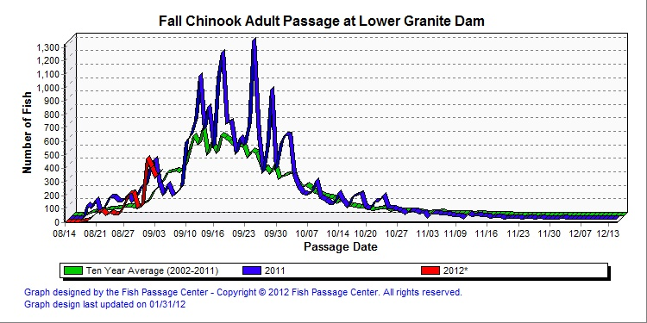

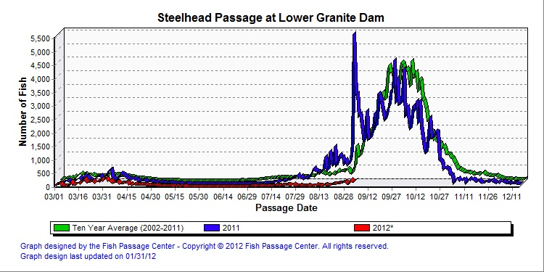

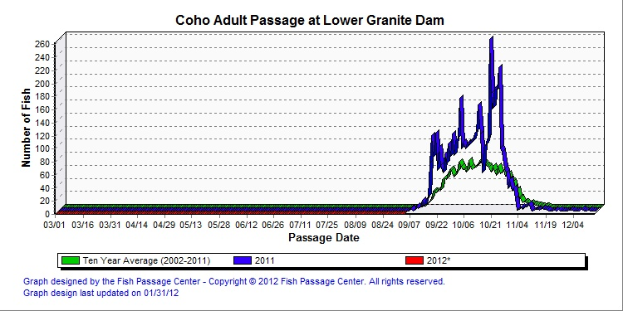

Comments From Agencies:

-----Original Message-----
From: Bill Hevlin [mailto:bill.hevlin@noaa.gov]
Sent: Wednesday, September 05, 2012 2:59 PM
To: Fone, Kenneth R NWW
Cc: Bailey, John C NWW; Baus, Douglas M NWD; BPA Scott Bettin; Dave Benner; Ed Meyer (ed.meyer@noaa.gov); Fredricks, Gary; Haeseker, Steve; Jason Sweet; Kiefer,Russell; Klatte, Bernard A NWP; Kruger, Rick; Langeslay, Mike J NWP; Lorz, Tom; Mackey, Tammy M NWP; Moody, Gregory P NWW; Paul Wagner; Richards, Steven P (DFW); Setter, Ann L NWW; Shutters, Marvin K NWW; Stansell, Robert J NWP; Stephenson, Ann; Swenson, Larry; trevor.conder@noaa.gov; Wills, Dave; Wright, Lisa NWD; Cordie, Robert P NWP; Dykstra, Timothy A NWD; Ebner, Laurie L NWP; Eppard, Matthew B NWP; Faulkner, Donald L NWD; Feil, Dan H NWD; Hausmann, Ben J NWP; Holm, Leanne NWP; Hurd, Terry W NWP; Johnson, Kimberly O NWD; Keller, Paul S NWP; Lear, Gayle HQ @ NWD; Medina, George J NWP; Moynahan, Kevin NWP; Ocker, Paul A NWD; Peters, Rock D NWD; Proctor, William D NWD; Rerecich, Jonathan G NWP; Richards, Natalie A NWP; Royer, Ida M NWP; Schneider, Carolyn B NWP; Tackley, Sean C NWP; Traylor, Andrew NWP; Van-der-leeuw, Bjorn NWP; Walker, Christopher NWP; Zorich, Nathan A NWP; Zyndol, Miroslaw A NWP; Dugger, Carl R NWW; Francis, Michael NWW; Fryer, Derek S NWW; Halter, Mike J NWW; Hockersmith, Eric E NWW; Holecek, Dean NWW; Juhnke, Steve D NWW; Melanson, George W NWW; Pinney, Chris A NWW; Plummer, Mark F NWW; Spurgeon, William F NWW; Tice, Benjamin J NWW; Trachtenbarg, David A NWW; Trumbo, Bradly A NWW; SKIT@critfc.org; Brooks, Francis C NWW; Hamernik, David R NWP; Aaron Jackson; Alan Brower; Ballinger, Dean; Bob Rose; Brandon Chockley; Brian McIlraith; Charles Morrill (charles.morrill@dfw.wa.gov); Chris Caudill (caudill@uidaho.edu); Chris_Peery@fws.gov; Cutts, Matthew E NWP; Darren Chase; Statler, Dave; elmerc@nezperce.org; Erin Cooper; Filan, Benjamin J NWP; 'Fred Mensik' (lgrsmolt@gmail.com); Fryer, Jeff; Howard Takata; Jerry McCann; Juul, Steve T NWW; Kathryn Kostow; Khan, Fenton; Kinne, Eric B (DFW); Kovalchuk, Greg; Martinson, Rick; Olaf Langness; Patrick Luke; Petersen,Christine H (BPA) - KEWR-4; Roger Clark; Roger Dick Jr.; Rosanna Mensik; rreagan@usgs.gov; Scott Livingston; Shane Scott; Skidmore,John T - KEWR-4; Stricklin, Eric T NWP; Troy Humphrey; Tucker Jones; Warf, Don; Whiteaker, John; Carroll, Jerry A NWP; Kirk, Tony R NWP; Mettler, Rick A NWP; Perletti, Kevin P NWP; Schwartz, Dennis E NWP; Hunter, Patrick J NWP; Lewis, Rob NWP; Smith, Glen A NWP; Stocks, Dennis C NWP; Armstrong, Tamera L NWP; Duvall, David J NWP; Salber, Frank J NWP; Twiner, Ronald D NWP; Mettler, Lonnie E NWW; Eskildsen, Robert D NWW; Salgado, David J NWW; Smetana, Bruce A NWW; Mendiola, Marty T NWW; Weston, Dwayne M NWW; Werner, Richard D NWW; Valentine, Andrea L NWW
Subject: Re: FPOM: 12LGR 011 (EDG) Black Start Testing (UNCLASSIFIED)

Ken,
Thanks for the update on black start testing at Lower Granite. NOAA Fisheries has no problem with shifting the AUX pump outage to September 13, and after 1730 hrs in the afternoon. Please keep us informed on progress.
Bill Hevlin

Final Results:

OFFICIAL COORDINATION REQUEST FOR
NON-ROUTINE OPERATIONS AND MAINTENANCE

COORDINATION TITLE- 12 LWG 011 Power House Emergency Diesel Generator (EDG) Black Start Testing.
COORDINATION DATE- 28 Jun 2012, 1 st UPDATE 24 July 2012. 2nd update August 22, 2012
PROJECT- Lower Granite Lock and Dam
RESPONSE DATE- 13 Jul, 2012 July 24, 2012 COB, August 29, 2012 COB.

Description of the problem
During the evolution of our Black Start Recovery testing of our Power House EDG, we will lose power to Station Service Switch Gear, which will take the Fish AUX Pumps offline, multiple times for approx 10 minutes per test. The Fish Pumps will be the restoration priority during each phase of testing as we do understand their critical value to adult fish passage.
1 st Update: 24 July 2012
Ann,

Last week's testing activities occurred as planned and without any problems. All testing took place on Tuesday only and no fish outages took place last Wednesday (8/18). However the contractor was unable to complete the test and therefore I would like to see if it would be okay to finish testing this Wednesday (8/25). This testing will be similar to the one conducted last week causing up to 5 different intermittent fish pump outages (5 to 10 minutes in duration) from 5:00 p.m. to 9:00 p.m.

Let me know if this is acceptable.

2nd update: August 22, 2012
Greg,

Previous testing activities occurred as planned and without any problems. However the contractor did not wire the CT’s properly, this was identified during the previous test however due to time constraints, the contractor was unable to make the proper corrections and (re-wire the CTs) and the problem was fixed through changes in the programming of the generator control program. Therefore I would like to see if it would be possible to have the contractor come back and perform all necessary corrections and once the corrections have taken place a test would be performed to verify that all repairs work as intended. All work will require two different outages. The first outage would be necessary to re-wire the CTs and would result in having only one fish pump operating for a period of no longer than one hour, this outage would occur anytime between 1500 and 1700. The second outage would be required to perform a blackstart test similar to the one that was performed on July 25^{th.} The testing outage will cause the fish pumps to be out from 1730 hrs. to 1930 hrs.

Type of outage required
One day outage for approximately 10 minutes per each configuration tested, over a 4 hour testing period.

One 1-hour long outage to perform wiring correction activities and one 2-hour long outage to perform all testing activities.

Impact on facility operation
The Impact will be temporary loss of Fishway Pump Auxiliary Adult Fish Attraction Water for short, 10 minute periods during the morning passage. The original completion dates for EDG Replacement were expected in Feb/Mar, but the testing of our EDG has been extended into the Adult Fish Passage Times, due to the extended installation timeline. Otherwise this would have been annotated in the FPP. We would like to finalize the installation of the new EDG to facilitate stable backup power during unforeseen emergency operations. This final testing will also allow our Operators to learn the restoration procedures to support the Dam and future power failures.

Dates of impacts/repairs
17-18 Jul 2012. Update: testing rescheduled for July 25, 2012. 2nd update scheduled for August 30, 2012

Length of time for repairs
Approximately 10 minutes for each tested configuration, during approximately 4 hours that morning. (1700 – 2100). There will be 5 different configurations tested over a four hour period. Hope to be complete on the 17th, 18th is backup.

Approximately 1 hour for repairs (re-wiring) and 2 hours for testing.

Expected impacts on fish passage
We expect the impact to be minimal as we should still have good water flow into the Fish Ladder from the top end of fishway and diffuser 14. As well these outages are short duration and the impact to flows within the ladder will barely be noticeable. Just a minor fluctuation in input through the pumped diffusers, Diffusers 1-13 at a time of day when adult fish are not moving.

Impacts to adult fish passage should be minor given the short outage time. Flows down the actual ladder portion of the fishway will be maintained. Flows through the diffusers will obviously be reduced but only for a limited period of time. The prescribed outage time is later in the day when daily adult fish movements into the fishway system should have slowed down. This work does need to be done and conducting it prior to the main steelhead migration period during September and October has obvious benefits.

Comments From Agencies:

-----Original Message-----
From: Bill Hevlin [mailto:bill.hevlin@noaa.gov]
Sent: Friday, July 13, 2012 9:49 AM
To: Setter, Ann L NWW
Cc: Bill Hevlin
Subject: Re: Black start testing at LGR (UNCLASSIFIED)

Ann, thanks for the coordination, NOAA has no problem with these necessary short outages of the AUX water pumps.
Bill Hevlin

July 24, 2012:
Voice call with NOAA on July 24, 2012, – Bill Hevlin (NOAA) had no problem with conducting this test in the evenings between 5:00 pm and 9:00 pm.

From: Kiefer,Russell [mailto:russ.kiefer@idfg.idaho.gov]
Sent: Wednesday, August 22, 2012 3:13 PM
To: Moody, Gregory P NWW
Subject: RE: Black start testing at LGR (UNCLASSIFIED)

Greg,

We have no objections!

Russ

From: Bill Hevlin [mailto:bill.hevlin@noaa.gov]
Sent: Thursday, August 23, 2012 11:37 AM
To: Moody, Gregory P NWW
Cc: Setter, Ann L NWW; Bailey, John C NWW; Baus, Douglas M NWD; BPA Scott Bettin; Dave Benner; Ed Meyer (ed.meyer@noaa.gov); Fredricks, Gary; Haeseker, Steve; Jason Sweet; Kiefer,Russell; Klatte, Bernard A NWP; Kruger, Rick; Langeslay, Mike J NWP; Lorz, Tom; Mackey, Tammy M NWP; Paul Wagner; Richards, Steven P (DFW); Shutters, Marvin K NWW; Stansell, Robert J NWP; Stephenson, Ann; Swenson, Larry; trevor.conder@noaa.gov; Wills, Dave; Barton, Steven B NWD; Clugston, David A NWD; Cordie, Robert P NWP; Dykstra, Timothy A NWD; Eppard, Matthew B NWP; Faulkner, Donald L NWD; Feil, Dan H NWD; Hausmann, Ben J NWP; Hurd, Terry W NWP; Keller, Paul S NWP; Lear, Gayle HQ @ NWD; Medina, George J NWP; Ocker, Paul A NWD; Peters, Rock D NWD; Rerecich, Jonathan G NWP; Richards, Natalie A NWP; Schneider, Carolyn B NWP; Schwartz, Dennis E NWP; Tackley, Sean C NWP; Traylor, Andrew NWP; Van-der-leeuw, Bjorn NWP; Walker, Christopher NWP; Wright, Lisa NWD; Zorich, Nathan A NWP; Zyndol, Miroslaw A NWP; Dugger, Carl R NWW; FCRPS NWW; Fone, Kenneth R NWW; Fryer, Derek S NWW; Halter, Mike J NWW; Kirts, Linda R NWW; Melanson, George W NWW; Plummer, Mark F NWW; Spurgeon, William F NWW; Weston, Dwayne M NWW; Aaron Jackson; Ballinger, Dean; Bob Rose; Brian McIlraith; Charles Morrill (charles.morrill@dfw.wa.gov); Chris Caudill (caudill@uidaho.edu); Chris_Peery@fws.gov; Statler, Dave; elmerc@nezperce.org; 'Fred Mensik' (lgrsmolt@gmail.com); Fryer, Jeff; Jerry McCann; Kathryn Kostow; Kovalchuk, Greg; Martinson, Rick; Patrick Luke; Roger Dick Jr.; Rosanna Mensik; Shane Scott; Skidmore,John T - KEWR-4; Tucker Jones; Warf, Don; Whiteaker, John; Salgado, David J NWW
Subject: Re: Black start testing at LGR (UNCLASSIFIED)

Greg,
Thank you for the update on coordination request 12 LWG 011 Power House Emergency7 Diesel Generator. NOAA Fisheries agrees with your assessment that the additional short outage of the AUX pumps on August 29 will have minimal impact to adult passage, and has no problem with the Corps' request.

Bill Hevlin
Senior Fisheries Biologist
NOAA Fisheries

